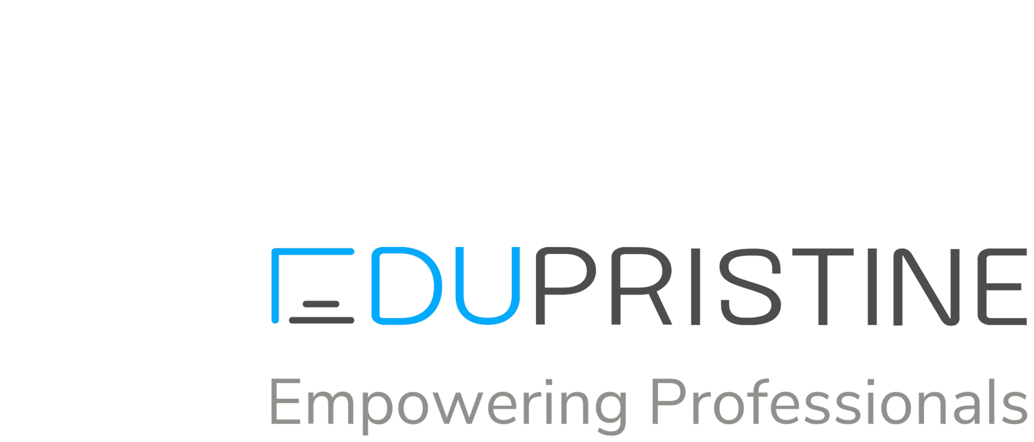

For [Certified Public Accountants]

(Confidential)

**© EduPristine**

**Certified Public Accountant (US CPA)**



**© EduPristine**

Certified Public Accountant (CPA) is a globally recognized designation and is the highest standard of competence in Accountancy. The CPA course exam is administered by the American Institute of Certified Public Accountants ([AICPA](https://www.aicpa.org/)), which is the world’s largest accounting body.

The CPA course is extensive and covers accounting topics and other topics like law, analytics, taxation, auditing, evaluation, regulatory frameworks and procedures, ethics, planning and management of finances.

With the increasing number of MNCs establishing in India and Indian companies going Global, there are abundant opportunities for candidates who understand the Foreign Accounting Principles & Standards. This makes US CPAs one of the most sought-after professionals in the field of Finance & Accounting. US CPA Program certification opens doors to a wide variety of career options including Assurance Services, Forensic Accounting, International Accounting, Internal & External Auditing, Tax & Financial Planning, Consulting Services, to name a few.

Earlier, students had to appear for US CPA exams in the United States or Middle East countries. Since January 2021, students can appear for the CPA exams in India in Ahmedabad, Bangalore, Calcutta, Chennai, Hyderabad, Mumbai, New Delhi, and Trivandrum.

**US CPA - Certified Public Accountant**

▪

**© EduPristine**

**Finance / Accounting Skills in Demand**

Treasury and Tax

▪

Financial Management & Control

▪

Audit

▪

Risk & Compliance

▪

Business & Financial Analysis

▪

**US CPA - Certified Public Accountant**

**© EduPristine**



Bachelor’s degree or higher

**US CPA - Certified Public Accountant**

**© EduPristine**

**Education Requirements**

A few States allow registration at 120 credits for the CPA exams

▪

•

150 academic credits with 24 Accounting and 24 Business credits

•

General rule

▪

Varies from State to State

▪

**US CPA - Certified Public Accountant**

**© EduPristine**



State - California

**Eligibility Criteria for Indian Students**

Must be qualified from A ranking universities and the candidate must have first division throughout the study. Refer to the degree equivalency tool to verify

https://applications.wes.org/degree-equivalency-tool/

**B.COM**

▪

▪

**US CPA - Certified Public Accountant**

**© EduPristine**



▪

State - Alaska (AK) via NIES

**B.Com + CA Inter or B.Com + M.Com Part 1 (with a course completion certificate)**

State - California (CA) or Alaska (AK)

**BCOM + CA or ICWA (with membership certificate)**

State - Alaska via NIES

**Eligibility Criteria for Indian Students**

▪

▪

**BCOM + MCOM or BCOM + MBA**

8

**US CPA - Certified Public Accountant**

**© EduPristine**



Submit payment slip for exam

**US CPA - Certified Public Accountant**

**© EduPristine**

Receive Notice-to-Schedule (NTS)

•

Earn your CPA Designation

**Prepare**

**Schedule**

•

Review state requirements

•

Submit your application

•

•

Obtain work experience

•

Create your study plan

•

Study with Becker

•

Schedule exam with Prometric

**© EduPristine**

**Steps to Becoming a US CPA**

**US CPA - Certified Public Accountant**

**Qualify**

**Apply**

**Succeed**

•

Sit for and pass the CPA Exam

•

Take ethics exam (where applicable)

•

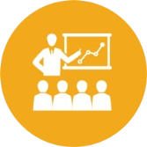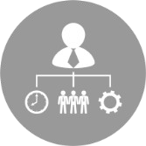

Professional skepticism

Business environment

and processes

Effective communication skills

Professional and Ethical responsibilities

Higher-order cognitive skills

**In addition to professional content knowledge, the AICPA will now require newly licensed CPAs to possess:**

**Current version of the Uniform CPA Exam**

**© EduPristine**

**Key Details**

**US CPA - Certified Public Accountant**



**Upon passing the 1 section, complete the remaining 3 sections within 18 months**

**Exam Timeline**

**© EduPristine**

**US CPA - Certified Public Accountant**

•

Start studying before you receive your NTS

**Apply**

**Obtain NTS ( 6 months )**

The application can take 15 to 20 days to process

•

•

Once you pass the first part, you have 18 months to complete the remaining sections

•

Gain 1-2 years of experience and obtain the CPA License



**US CPA - Certified Public Accountant**

For [Certified Public Accountants]

(Confidential)

**© EduPristine**

Thank You!