Certified Public Accountant
Exam Structure (US CPA)
For [Certified Public Accountants]
(Confidential)
© EduPristine
Till December 2023, candidates will have to appear for the below exams:
- Exam I: Financial Accounting & Reporting (FAR)

- Exam II: Auditing & Attestation (AUD)

- Exam III: Regulation (REG)

- Exam IV: Business Environment & Concepts (BEC)

From January 2024, candidates will have to appear for the below exams:
- Exam I: Financial Accounting & Reporting (FAR)

- Exam II: Auditing & Attestation (AUD)

- Exam III: Regulation (REG)

- Exam IV: Candidates will have to choose and pass one of the following:
- Business Analysis and Reporting (BAR)
- Information Systems and Controls (ISC)
- Tax Compliance and Planning (TCP)

US CPA Exam Topics
© EduPristine

US CPA - Certified Public Accountant
© EduPristine

Exam Structure by Section
US CPA - Certified Public Accountant

Section | AUD | BEC | FAR | REG
Multiple-Choice Questions (MCQs) | 50% | 50% | 50% | 50%
Task-Based Simulations (TBSs) | 50% | 35% | 50% | 50%
Written Communication Tasks | n/a | 15% | n/a | n/a

Section | AUD | BEC | FAR | REG
Multiple-Choice Questions (MCQs) | 72 | 62 | 66 | 76
Task-Based Simulations (TBSs) | 8 | 4 | 8 | 8
Written Communication Tasks | 0 | 3 | 0 | 0

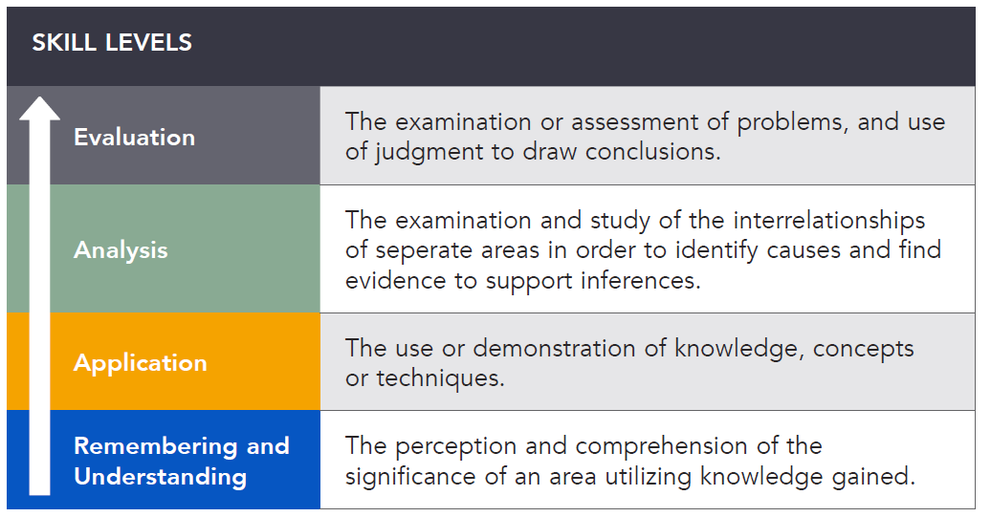
© EduPristine

Skill Level
US CPA - Certified Public Accountant
© EduPristine

Skill Level
US CPA - Certified Public Accountant

Section | Remembering and understanding | Application | Analysis | Evaluation
AUD | 25–35% | 30–40% | 20–30% | 5–15%
BEC | 15–25% | 50–60%* | 20–30% | —
FAR | 10–20% | 50–60% | 25–35% | —
REG | 25–35% | 35–45% | 25–35% | —

Federal Taxation of Property Transaction
Information Technology
15–25%
Operations Management
5–15%
BEC
Corporate Governance
17–27%
15–25%
Economic Concepts and Analysis
17–27%
Financial Management
11–21%
15–25%
Entity Federal Taxation
Individual Federal Taxation
28–38%
Business Law
REG
Professional Responsibilities, Ethics, and
Federal Tax Procedures
10–20%
10–20%
12–22%
15–25%
Assessing Risk and Developing a
Planned Response
20–30%
Performing Further Procedures and
General Principles
Obtaining Evidence
30–40%
Forming Conclusions and Reporting
© EduPristine

Question Content Allocation
US CPA - Certified Public Accountant
AUD
Professional Responsibilities, Ethics and
30–40%
Transactions
20–30%
Local and State Governments
Financial Statement Accounts
15–25%
FAR
Standard-Setting, Conceptual
Framework, and Financial Reporting
25–35%
© EduPristine

US CPA - Certified Public Accountant
© EduPristine

Break Rule
US CPA - Certified Public Accountant

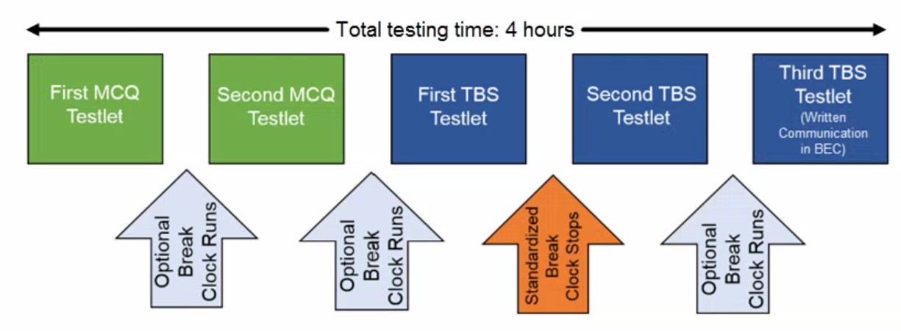
Each CPA section/exam duration: 4 hours
Candidate needs to complete/clear all 4 CPA exams within 18 months.

Candidates can schedule their CPA exam in India at Prometric test centers in Ahmedabad, Bangalore, Calcutta, Chennai, Hyderabad, Mumbai, New Delhi, and Trivandrum.

For [Certified Public Accountants]
(Confidential)
© EduPristine
Thank You!

