Economics

- It is the currency exchange rate for immediate delivery, which for most currencies means that the exchange of currency takes place two days after the trade.
- Transactions that had to be settled immediately like trading of equity are a part of this market.
- Settlement period is two business days after the trade.
Spot FX Markets:
Forward FX Markets:

- 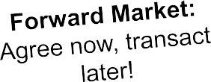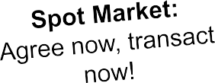Transactions that will be settled in the future are included in the forward FX markets.
- Exchange of currencies takes place in future at the exchange rate agreed today.
- Forward contracts are generally for 30,60,90 and 180 days.
- This market allows the firm to hedge against the exchange rate uncertainty or fluctuations.
- Forward rate can be greater or less than the spot exchange rate.
- Forward exchange rate represents the interest differential between two countries.

Two Kinds of Quotes

Direct Quote

Indirect Quote

  - Price of one unit of foreign currency in terms of domestic currency
  - Exchange rate of INR/$ is a direct quote for Indian citizen
  - It tells the value of 1 unit of foreign currency in terms of domestic currency to domestic resident
- Price of one unit of domestic currency in terms of foreign currency
- Exchange rate of INR/$ is an indirect quote for the US citizen
- It tells the value of 1 unit of domestic currency in terms of foreign currency to US resident

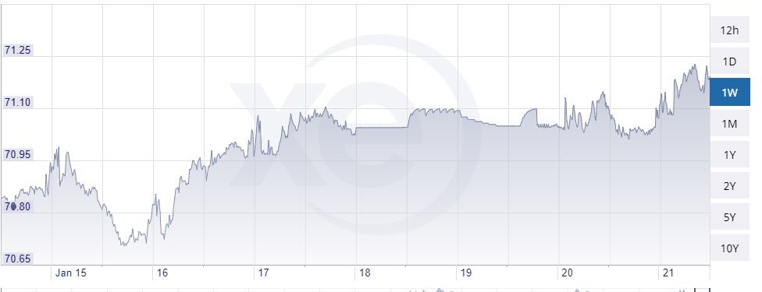
70.78 ASK (Buy)
70.70 SPREAD
BID (Sell)
INR/USD

- Ask price (also known as offer price) is always greater than the bid price.
- The difference is the compensation that counterparties seek for providing foreign exchange to the other market participants.
Bid-ask spread (for base currency) = Ask quote – Bid quote
Spread can be expressed as a percentage of ask price, bid price, or mid point between the ask and bid price.

Spread as a percentage of ask price = (0.11/ 46.03) * 100 = 0.2389%

Factors Affecting Dealer Spreads:
- The spreads in the interbank market for the two currencies involved
- The size of the transaction size
- The dealer-client relationship

Factors Affecting Interbank Spreads:
- The currencies involved – high volume currency pairs command lower spreads than low volume currency pairs
- Time of day – when most of the key markets are open and functioning
- Volatility in the currency pair Market Volatility – Spreads are directly correlated with the exchange rate volatility of the currencies involved and change over time in respond to volatility changes

Factors Affecting Spreads in General:
- Market conditions – Higher volatility in exchange rate markets increases the spread
- Trading volume – High trading volume leads to narrowing of spreads
- Bank or dealers’ position – Stock of currency with dealer leads to changes in spreads and adjustments in the mid point of spread
- Length of forward contract (maturity) – Longer maturity forward contracts have higher spreads owing to uncertainties in future

Cross Rate Bid:
- Assume, we want to exchange GBP with INR and determine bid between INR/GBP
- Sell GBP and buy $. Thereafter, sell $ and buy INR
- Results in cross bid
- Selling base currency in INR/GBP
Cross Rate Ask:
- Assume, we want to exchange INR with GBP and determine ask between INR/GBP
- Sell INR and buy $. Thereafter sell $ and buy GBP
- Results in cross ask
- Buying base currency in INR/GBP

Forward Premium: When, | Forward price (in units of the second currency) > Spot price

Forward Discount: When, | - Forward price (in units of the second currency) < Spot price
- If one currency is in premium, then the other is in discount.
- Use mid-points of bid ask to calculate the annualized forward premium or discount if the bid-ask spot and forward quotes are given in exam.
- However, if in exams, spot rates and interest rates are given (domestic and foreign), use the formula mentioned in forward rate parity in future slides.

If the forward contract price is consistent with covered interest rate parity, the value of the contract
at initiation is zero to both parties. After initiation the value of the forward contract will change as forward quotes for the currency pair change in the market. The value of a forward contract (to the party buying the base currency):
At maturity (time T):
VT = (FPT - FP) X (contract size)

Where:
T = maturity of the forward contract
FP = forward price locked in at inception to buy base currency (and with a maturity of T)
FPT = forward price to sell the same currency at time T = ST
Contract Size = number of units of currency covered by the agreement

Exchange Rate Management: Intervention and Controls

An excessive appreciation or depreciation of currency can lead to several problems. Hence, a government intervention is sometimes inevitable.

The objectives of the capital controls or central bank intervention in FX markets are to:

Ensure that the domestic currency does not appreciate excessively.

Allow the pursuit of independent monetary policies without being hindered by their impact on the currency values.

Reduce the aggregate volume of the inflow of foreign capital.

Exchange Rate Management: Intervention and
Controls (Cont.)

Examples of better economic management by a government include:
A decrease in inflation and inflation volatility
More-ﬂexible exchange rate regimes
Improved fiscal positions
Privatization of state-owned entities
Liberalization of financial markets
Lifting of the foreign exchange regulations and controls

Thank You!

© EduPristine For [CFA® Program Level-II] (Co
Disclaimer: The content is partially owned by CFA Institute, such as k
nfidential)
nowledge check, examples, diagrams, etc.

