

**Financial Markets and Products**

r



Group Life insurance

employers arrange on behalf of employees



There are three types of insurances: Life Insurance

Non-life Insurance Health Insurance

**Types of Life Insurance**

provides a specified amount of coverage for a fixed period

Term Life insurance

Whole Life insurance

provides a specified amount of coverage for life. There is a surplus premium in initial years of life insurance and deficit in later years

Endowment Life insurance

a subset of ‘Term Life Insurance’, has a pay-out at pre-defined maturity if policyholder lives

Annuity contracts

opposite to insurance, a lump sum payment is made to receive a stream of future payments

# Pension Plans



**Two types of Pension plans**

**Defined Contribution Pension Plans**

**Defined Benefit Pension Plans**

* The difference between them is in DC plans the funds are identified individual employees while in DB plans all contributions are pooled and payment to retirees are made out of the pool.
* DB plan is a liability of the employer and underfunded DB plan is a direct reduction in the equity of the company.
* Longevity risk is a major concern for the pension plans.



### Mutual Funds

* It pools the funds from many small or mostly retail customers to meet specific investment objective.
* It provides diversification and professional management benefits to the small investors.

### Three types of long-term funds

* Bond funds that invest in fixed income securities with a life of more than one year.
* Equity funds that invest in common and preferred stock.
* Hybrid funds that invest in stocks, bonds, and other securities.

### Category of Mutual Funds

* Open Ended Funds and
* Closed Ended Funds.



**Index Funds**

* These types of Mutual Funds track a particular type of Index
* Measures used to analyze Index Funds:
  + Tracking Error
  + Expense Rati



**Costs involved in investing in Mutual Funds**

* Front End Load
* Back End Load
* Management Expense
* Distribution costs

Hedge Funds are pooled investment vehicles generally suited for high net-worth individuals and sophisticated institutions.

Hedge funds are riskier as they invest into convertible bonds, Credit Default Swaps, distressed debt, non-investment grade bond markets etc.

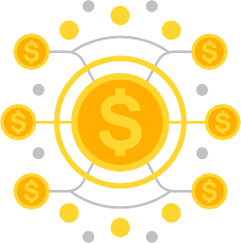

They may employ extensive leverage.

They are very less regulated as compared to other investment vehicles.

**© EduPristine**

For [FMP] (Confidential)

Derivatives are financial instruments which derive their value from an **underlying asset** and some other variables such as interest rates, volatilities, etc.

The **underlying asset:** It is a more basic financial instrument. Example: stocks, bonds, interest rate, commodity etc.

Futures, forwards, options, and swaps are some of the most common examples of derivatives.

* Payoff is non-linearly related to the underlying asset value.
* Example, Options.
* Holder has the right instead of obligation.

**Non-linear Derivative**

**There are two categories of Derivatives**

* Payoff is linearly related to the underlying asset value.
* Example: Forwards, Futures, etc.
* Usually an agreement to buy/sell at a specified price at a future date/time.

**Linear Derivative**

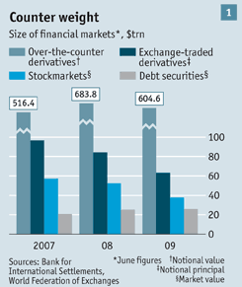

### Exchange Traded Markets

* Market where individuals trade standardized contracts that have been defined by the exchange themselves.
* An Exchange acts as an intermediary which facilitates a regulatory oversight and hence makes the markets a safer place for trading.
* Chicago Board of Trade and Chicago Mercantile Exchange are two examples.
* Open outcry system and Electronic trading.

### Over-the-counter Markets

* There is no intermediary and no standardized contracts; parties create their own T&C with each other.
* Much larger than the exchange traded market in terms of value of underlying assets (more than 4 times larger).
* Trades done between financial institutions or between financial institutions and clients. Financial institutions act as a market maker (quotes both bid and ask).

Source of Graph: The Economist

Futures Contracts: This is an agreement to buy or sell an asset for a certain price at a certain time. A futures contract is exchange traded.

Forward Contracts: Forward contracts are similar to futures except that they are over-the-counter.

▪

Notation for Valuing Futures and Forward Contracts:

* S0: Spot price of the asset underlying today
* F0: Futures or forward price today
* T: Time until delivery date (in years)
* R: Risk-free interest rate per annum, expressed in continuous compounding, for maturity T



Options are contracts that give its buyer the right but not the obligation to buy or sell a particular asset.

A few of its specifications are:

In the future and at a pre-decided price, i.e., exercise or strike price Without any obligations

Traded both on exchanges and over the counter markets

One option contract is to buy/sell 100 shares in the U.S

The seller of the option collects a payment (Premium) from the buyer for providing the option.

**Types of options:**



**Call or Put Options**

* **Call Option:** Gives option holder the right but not the obligation to buy the asset at an agreed price.
* **Put Options:** Gives option holder the right but not the obligation to sell the asset at an agreed price.

### European or American Options



* + **European options:** Are those that can only be exercised on expiration.
  + **American options:** May be exercised on any trading day on or before expiration.

**Hedgers:**

* Use derivatives to hedge the risks they face from volatility in the market variables.
* Main objective is to reduce or eliminate risk and not maximize profits.

**Speculators**

* Use derivatives to bet on the direction of movement of market variables. They either bet on the prices going up or down.
* Main objective is to make money on the bet.



It must be remembered that the purpose of speculating is to make profits by betting on the direction of the movement of the prices.





It must be remembered that the purpose of arbitraging is to take advantage of mispricing to book riskless profits.



▪

Take offsetting positions simultaneously in two or more instruments to lock a profit now.

▪

Main objective is to take advantage of price difference

**Arbitrageurs**

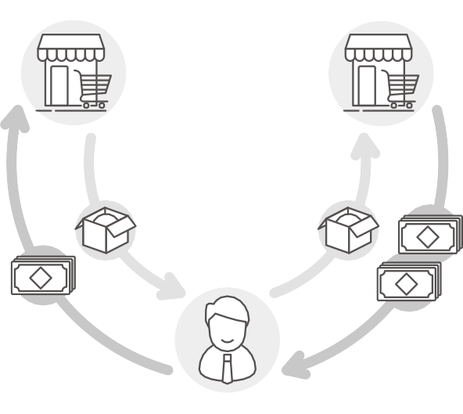

**Clearing House**



**Investor**

**Broker**

**Trader**

**Clearing House Member**



**Exchange**

|  |  |  |
| --- | --- | --- |
| **Specifications of a Contract** | **Margins** | **Clearing House Margin** |
| * Asset: If asset is a commodity, exchange specifies the asset in complete detail: grade, quality, size, shape, color, etc. * Contract size: The amount of the asset to be delivered * Delivery arrangement: place of delivery * Delivery month | * Margin account: Investor deposits a certain amount of money with the broker in the margin account * Initial margin: the initial amount deposited in the margin account * Maintenance margin: Is somewhat below the initial margin. The minimum amount after which a margin call is sent to the investor. After margin call investor has to top his margin account to the initial margin. | * If not the broker a clearing house member has to be a member of the clearing house * Clearing margin: Just like a margin account with a broker, members have an account with the clearing house * No maintenance margin * Account balance to be maintained at all times = number of contracts * original margin |



Thank You!

**© EduPristine** For [FMP] (Confidential)

