Macros

- Excel is one of the most widely used tools in financial industry
  - Easy to use
  - High reach & access to software across geographies
  - Flexibility
  - Robustness
  - Inbuilt features (Most people would not even be using 95% of the features) & Extendibility
  - Modular and Object-Oriented Architecture

- Applications, typically requiring back-end calculations can be built using simple Excel
  - Poor user interaction
  - Not that flexible
  - Cannot run for “multiple instances”

- Applications building in Excel require understanding of advanced features and functions
  - To collect user inputs in a nice fashion, Graphical User Interface (GUI) can be built
  - To perform any repeated task excel provides Macro Recording
  - To generate complex functions, you can use excel functions
  - To perform complex calculations and operations, Excel VBA (Macros) can be used

- Most applications would require the task to be done for multiple iterations
  - For example, formatting charts, etc.
  - For simple routine tasks, Macros can be recorded and used
  - VBE can be used to programmatically perform routine tasks repetitively for complex calculations

Macros are like
Robots!!
Create
Graphical User Interface (GUI)
Automate
Routine Tasks by Recording
Automate
Routine Tasks by Programming

- A macro is a set of computer instructions
  - A mini-computer program
  - Activated by an event
  - That tells the computer what to do

    - Typically, the first level of Macro can be created by Recording the macro
Train the Robot
    - A little bit of understanding of VB can help improve the usability multi-fold
Use the Robot
Retrain
The Robot is as good as you have trained it!

Reuse

- Right click on any existing ribbon tab and choose customize the ribbon. Check the developer tab
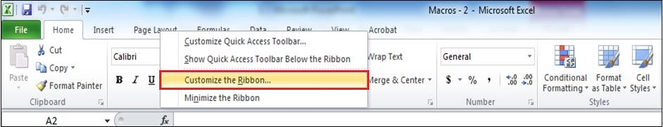box and click OK.
1
Right click on existing tab and choose customize the ribbon

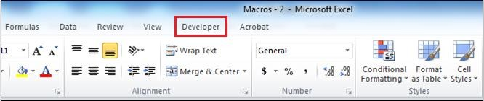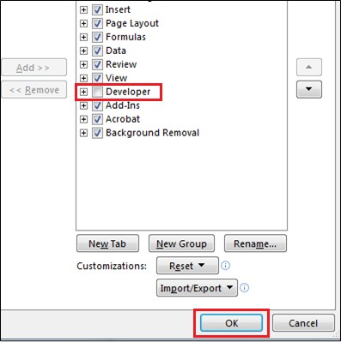Now developer tab
2
Check the
developer tab box.
Click OK
3
is in the menu bar.
4

- Click on the developer tab on the ribbon and then Go to Visual Basic.
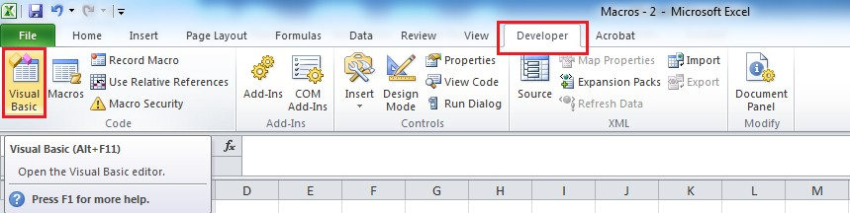

You can select the Visual Basic option under the developer tab or by using shortcut Alt+F11.

- The Visual Basic window is open.

- Click on the first button on the VB editor toolbar. It takes back to the excel. Switching between VB
Editor and Excel is also done by using keyboard shortcuts Alt+F11.

Click on the button for switching back to Excel from VB Editor toolbar.

Project Explorer
Run and Control Commands
Code Window

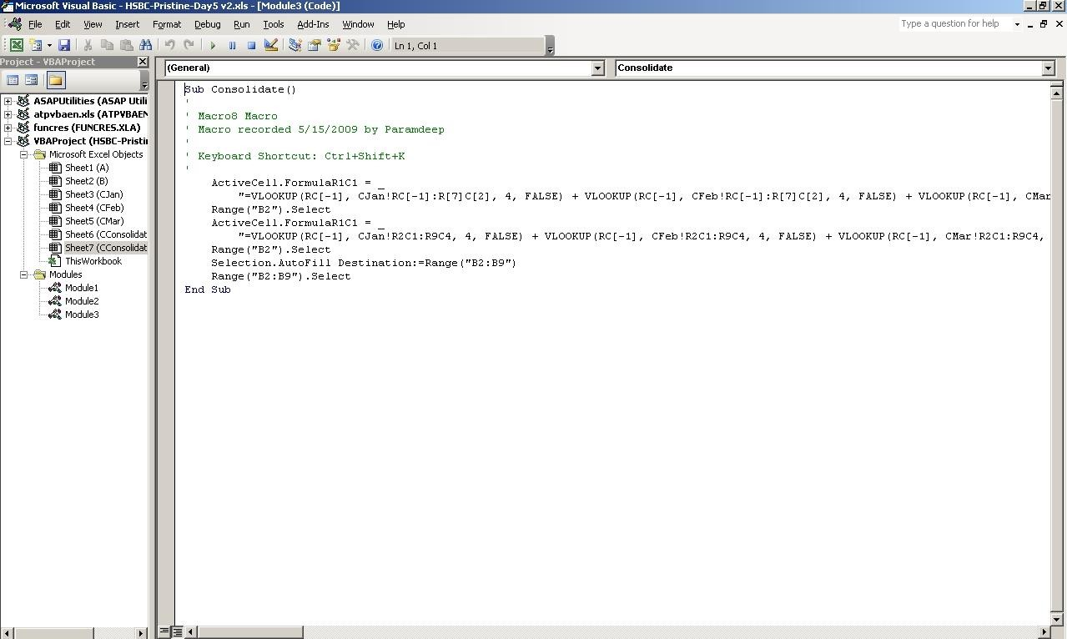

Use Alt + F11 to get the window

- For Project Explorer window, go to View>Project Explorer or use shortcut Ctrl+R.
- For Properties Window, go to View>Properties window or use shortcut F4.
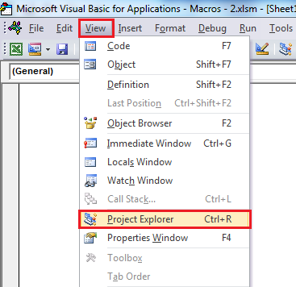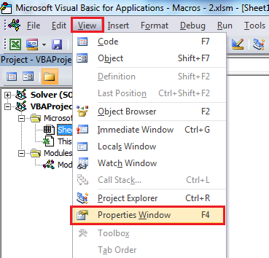
Go to Project explorer under the View tab for open the Project Explorer Window or use Ctrl+R shortcut.
Go to Properties window under the View tab for
open the Project Properties Window or use F4
shortcut.

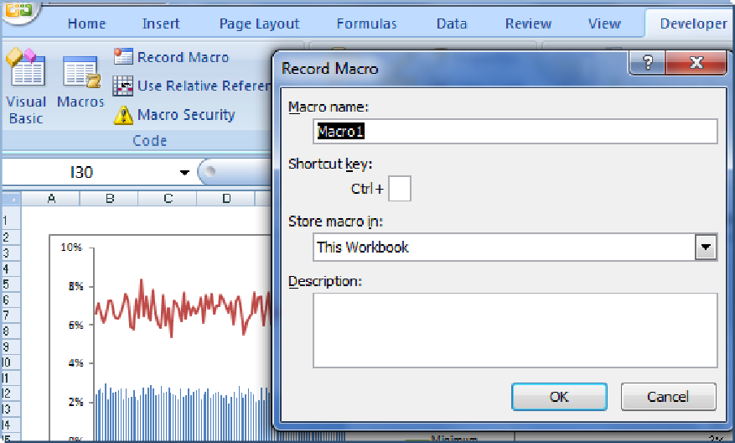
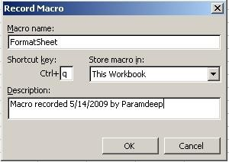
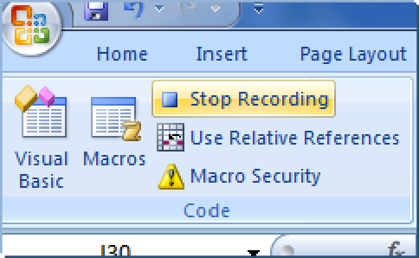
- Name the macro
- Shortcut key - fill in a letter in the available space
  - Allows you to run the macro by holding down the CTRL key and pressing the chosen letter on the keyboard
- Description
  - Description of the macro
Remember to Stop the recording!

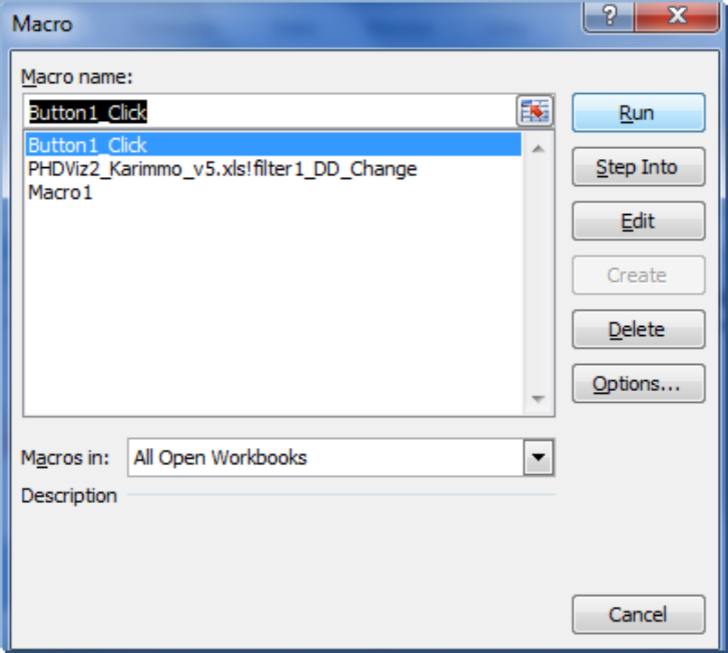

- Use the Run Macro or shortcut key assigned to run the macro

Use Par_01_CopyMe-MacroRecording

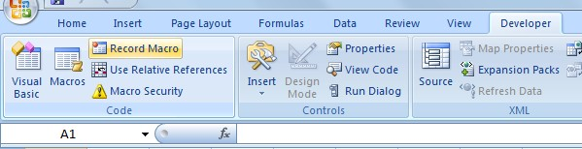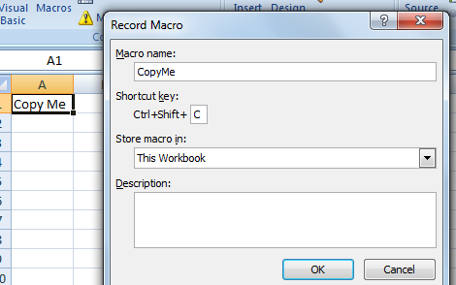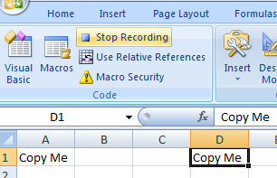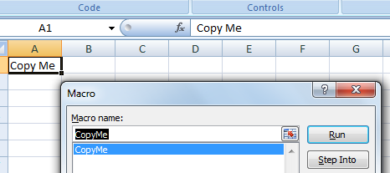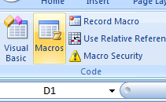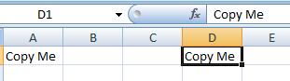

1 6

2 5

4
3

- Create a new macro
  - Record the steps performed to update the chart as per the standards required

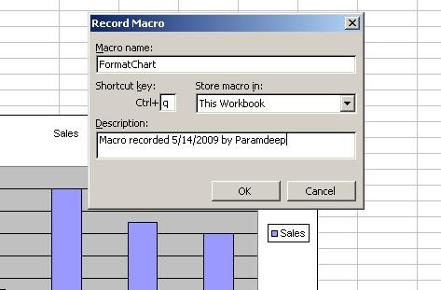

- 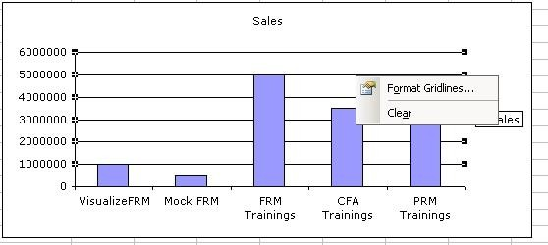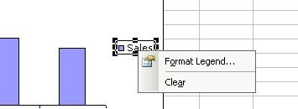Record all steps performed to change the formatting and stop the recording
1
2

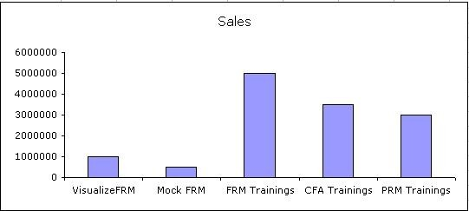
3

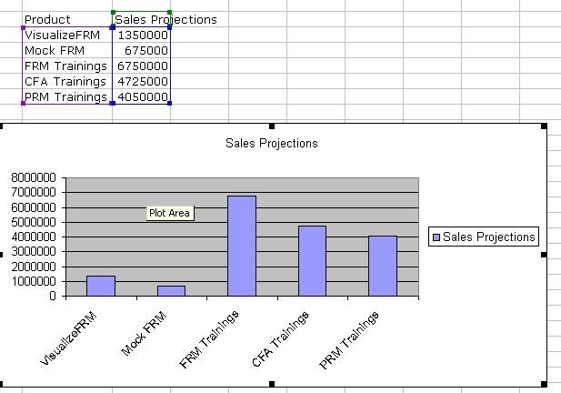

- Select the new chart that has to be formatted
  - Run the macro

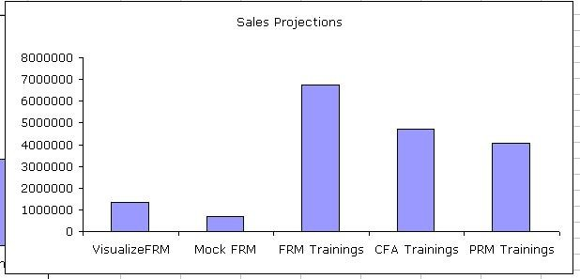

- With a single keystroke you can format your charts
  - For example B, CTRL + q is the key

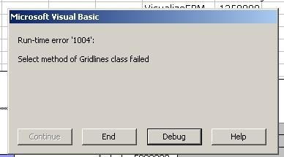
- Even small changes in the expected step would
cause the macro to throw errors
  - Need to understand the code
  - Slight modifications in the code can make the macros much more robust
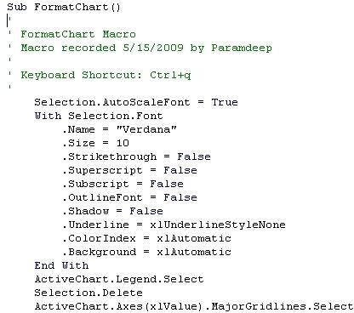

Thank You!

