Valuation

Business Valuation is the process of determining the "Economic Worth" of a company based on its Business Model under certain assumptions, limiting conditions and subject to data available on the valuation date. It is an important concept in corporate finance and business management.

Areas where valuation is used:

Areas | Description
Mergers & Acquisitions | Valuation is an important aspect of M&A. It not only assists  business owners in determining the value of their business, but  also helps them maximize the value when considering a sale, merger, acquisition, joint venture, or strategic partnership.
Voluntary Assessment | At times, the management wants to know the true value and fair  value of the business for which they undertake voluntary assessment for internal management purpose and  future decision making.
Going Public | In general, when a new company goes for an Initial Public Offering (IPO), it is doing so to generate capital for growing its business. In such a circumstance, they need to evaluate the fair value of the stock. The Indian Capital Market follows a free pricing regime, and thus the accurate pricing of an IPO is of immense importance.
Dispute Resolution | Valuation is an important aspect of many commercial disputes. Before deciding how to manage a dispute, it is necessary to determine the likelihood of a successful outcome and the potential stake involved. Judicial precedents are also available that affect the selection of valuation methodology and applicability of discounts/ premiums.

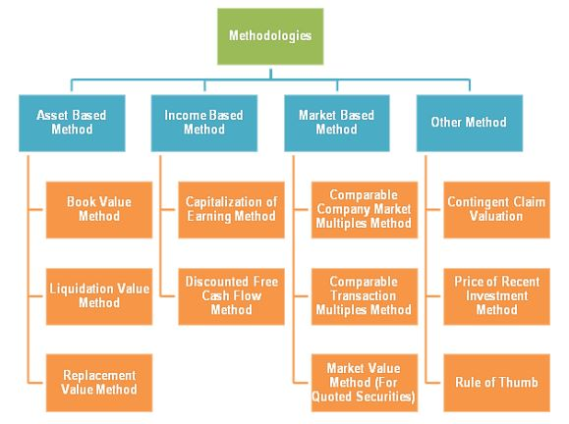

Asset Based Approach

The asset-based business valuation approach is based on the total value of all assets of the company.

The basis of asset-based approach depends on the assets and liabilities on the company’s balance sheet. The value of a company consists of assets and liabilities within the scope of this approach. The equity value is obtained by reducing the total value of the company’s liabilities from the total value of the company’s assets.

The proponents of this approach argue that an accounting-based company value estimate gives more accurate results than valuation models based on all predictive assumptions for the future. Indeed, the balance sheet elements give general picture of business value. However, it is not enough to give a complete and accurate picture. This approach is based on accounting records. Since it is a static valuation method, it does not take into account the future expectation of the company, the company’s situation in the sector, the future cash flows and the factors that are not reflected in the accounting tables such as the agreements made by the company.

Income Based Approach

The income-based business valuation approach is based on the expected future cash flows of the company.

This approach is also known as Discounted Cash Flow Valuation, where the value is determined by discounting future cash flows to the present using a required rate of return. The income-based business valuation approach is based on the future income to be generated by a company. According to this approach, a company can only create value as long as it generates cash in the future. Therefore, the present value of a company is determined by the present value of the cash flows of that company generated in the future.

In the income-based approach, the company’s future expectations are taken into account. Therefore, it is argued that this approach gives more accurate picture of a business's true value. However, it is difficult to calculate and is based on many projections. Because the calculations are mostly based on projections and predictions, the probability of bias increases due to human factors.

Market Based Approach

The market-based business valuation approach is based on the comparables in the market.

This approach is also known as relative valuation. In this approach, the value of the business is obtained by the comparison of the business with similar-class businesses and securities sold in the market. In other words, the real market values are examined to figure out what your business value is. The basis of market-based valuation is the assumption that similar assets will be traded at similar prices in efficient market conditions. Multiples (comparables) are used to obtain business value. There are several multiples within the Market Approach. When there are sufficient number of similar businesses/assets/securities in the market, the possibility of this approach working well increases.

Although this approach is simple and uses real market data, it sometimes might be difficult to find similar data. In addition, it is a difficult task to figure out if it is really similar and identified company or not. It is also sometimes very difficult to find enough comparable businesses according to the subject business. Therefore, this approach is not flexible. The expectations for the future of the company, and therefore related risks are also not fully included in this approach.

Thank You!

