Basics of Excel

© EduPristine

Excel is one of the most widely used tools in financial industry
- Easy to use
- High reach and access to software across geographies
- Flexibility
- Robustness
- Inbuilt features (Most people would not even be using 95% of the features) & Extendibility
- Modular and Object-Oriented Architecture
Excel as a data-store

- Easy to store and retrieve information
- Flexibility to put many data types in the same sheet
Functions and a range of features
- Excel is easily extendible to be used as a Modeling tool

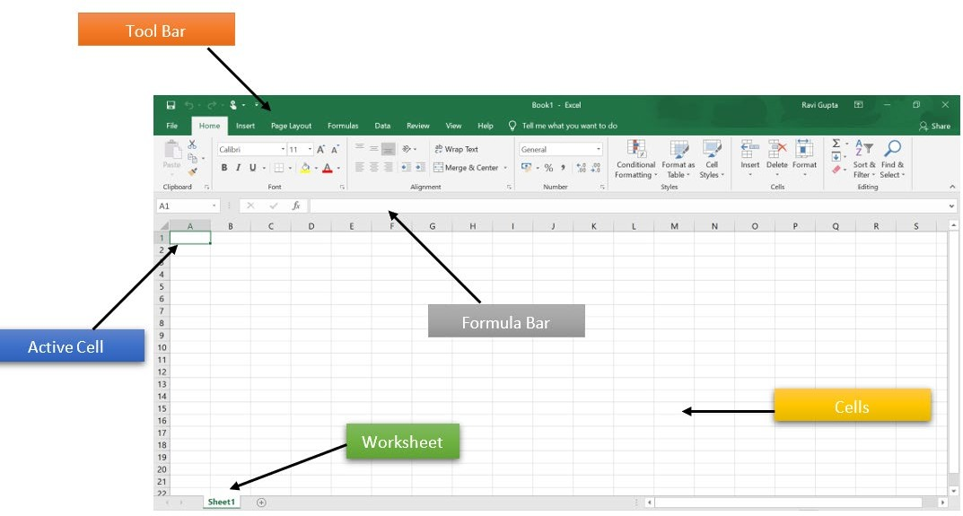

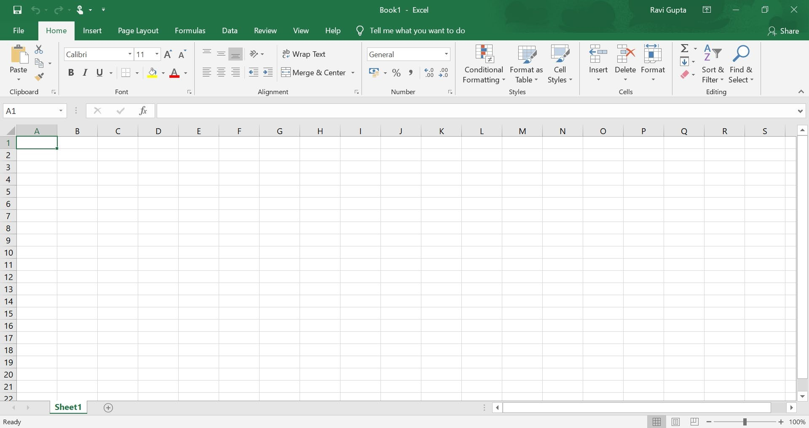

Basic Editing and Saving Excel
CTRL + S | Save workbook
CTRL + C | Copy
CTRL + V | Paste
CTRL + X | Cut
CTRL + Z | Undo
CTRL + A | Select all
CTRL + B | Bold
ALT + TAB | Switch program
ALT + F4 | Close program
CTRL + TAB | Switch workbooks

Formatting
CTRL + 1 | Format Box
ALT + H + 0 | Increase decimal
ALT + H + 9 | Decrease decimal
SHIFT + CTRL + ~ | General format
SHIFT + CTRL + ! | Number format
SHIFT + CTRL + # | Date format
SHIFT + CTRL + $ | Currency format
SHIFT + CTRL + % | Percentage format
CTRL + ; | Enter the date

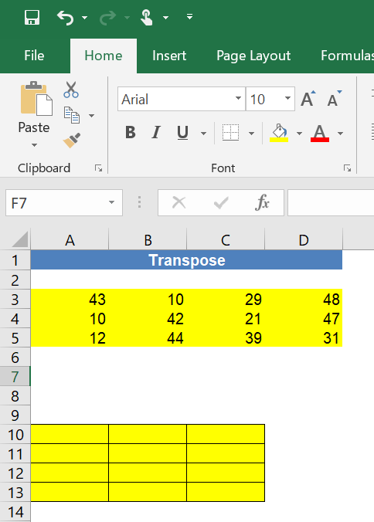
▪
Array (Can be loosely thought of as a list) is a group of cells or values that Excel treats as a unit.
- No longer treats the cells individually, but list of cells as an individual entity
- Since individual cells are not independent entities, so they cannot be changed individually
- Enables applying a formula to every cell in the range using just a single operation
▪
.
To Run Array Functions – Remember to use Copy + Alt E, S, E

Frequently Used Array Functions
Function Name | Function
SUMPRODUCT() | To Sum product 2 matrices
TRANSPOSE() | To transpose a matrix
MATCH() | Used in conjunction as a lookup function
INDEX() | Used in conjunction as a lookup function
VLOOKUP() | To lookup for a particular value in an array, with the starting column acting as a lookup reference
COLUMN() | Returns the column number of the cell referenced
ROW() | Returns the row number of the cell referenced
HLOOKUP() | To lookup for a particular value in an array, with the top row acting as lookup reference

- VLOOKUP() function
  - The V in VLOOKUP() stands for vertical
  - 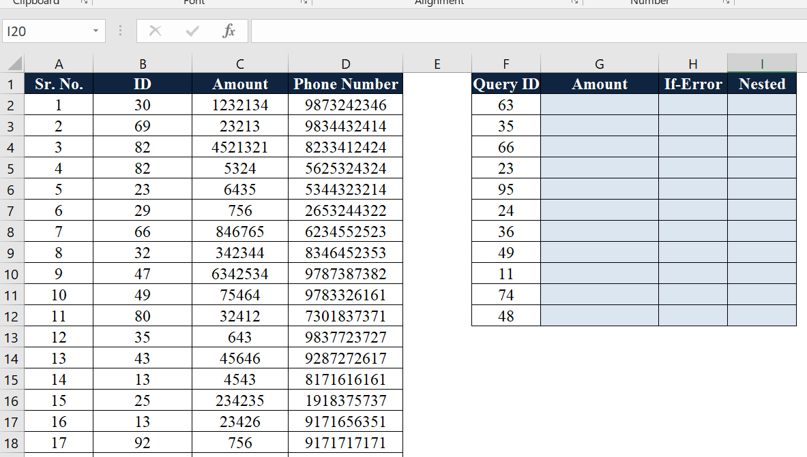Works by looking in the first column of a table for the value you specify
  - It then looks across the appropriate number of columns (which you specify) and returns whatever value it finds there
  - The final option (range_lookup) is a Boolean value that determines how Excel finds the value. Always use FALSE- for exact match
  - Whenever looking for data picked from the net, trim the strings before comparison
One of the most widely used functions in Excel.

▪
HLOOKUP() function
- H in HLOOKUP() stands for horizontal
- Similar to VLOOKUP()
- It searches for the lookup value in the first row of a table

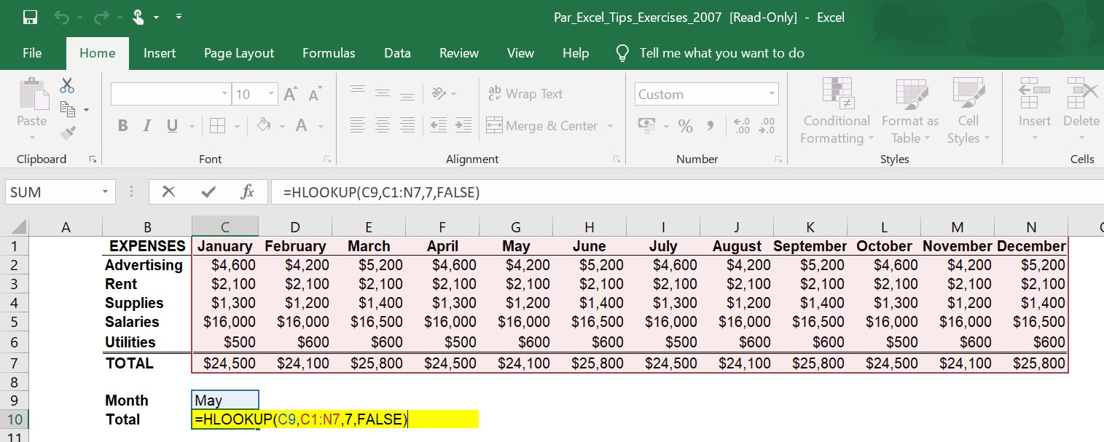
Both Vlookup and Hlookup have a limitation of using the first Column/ Row as a reference.
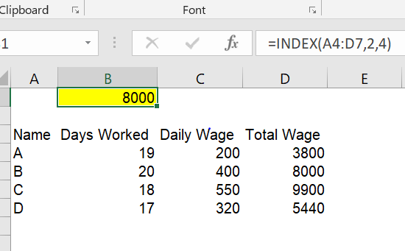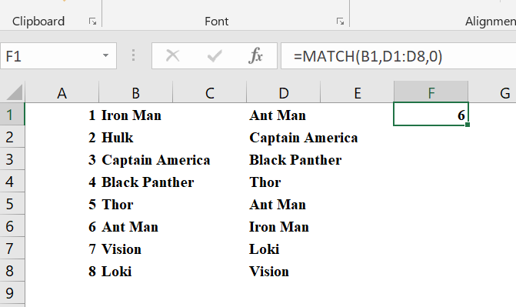
▪
INDEX() returns the reference or the value of a cell at the intersection of a row and column inside a reference.

▪
MATCH() function
•

•

Looks through a row or column of cells for a value
If it finds a match, it returns the relative position of the match in the row or column

Thank You!

© EduPristine

