Income Tax

Taxation, imposition of compulsory levies on individuals or entities by governments. Taxes are levied in almost every country of the world, primarily to raise revenue for government expenditures, although they serve other purposes as well.
A. Introduction

Business
Goods | + | Services | = | Profit
Manufacture | Trading
Excise Duty | Sales Tax (VAT/CST) | Service Tax |  | Income Tax Wealth Tax
Goods and Service Tax
 |  |  |  | Direct Taxes
Indirect Taxes

Types of Tax
Direct
Indirect

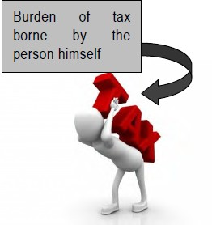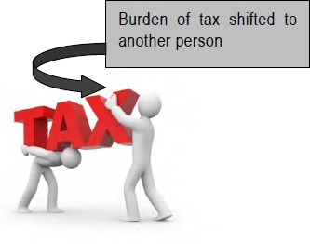
Burden of tax borne by the person himself
Burden of tax shifted to another person

B. Difference Between Direct Taxes and Indirect Taxes

CONTEXT | DIRECT TAX | INDIRECT TAX
Imposition | Imposed on income or profits | Imposed on goods and services
Taxpayer | Individuals, HUFs, firms, and companies | End-consumer of the goods and services
Applicability | Applicable to the taxpayer alone | Applicable to every stage of the production-distribution  chain
Tax burden | The burden falls directly on the individual | The burden is shifted to the consumer by the  manufacturer or service provider
Transferability | Cannot be transferred to anyone else | Can be transferred from one taxpayer to the other
Coverage | Confined to an entity or individual taxpayer | Wide coverage, because all the members of the society  are taxed
Administrative cost | Higher administrative costs and many exemptions | Lesser administrative costs because of stable, convenient  collections
Tax evasion | Possible | Not possible
Allocative effects | Have good allocative effects since they put less burden  on the collection | Allocative effects not as good as those of direct taxes
Inflation | Helps in reducing inflation | Might help in increasing inflation
Orientation | Discourage investments, lessen savings | Growth-oriented, encourage savings
Mode of progress | Progressive, reduce inequalities | Regressive, enhance inequalities
Most common types (in  India) | Income, Wealth, Corporate Tax | GST or Goods and Services Tax

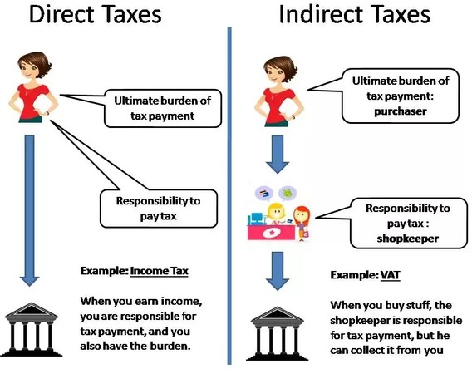

C. Introduction to Income Tax Act, 1961
- It came into force on 1st April ,1962.

- It undergoes changes every year, with additions and deletions brought out by the Annual Finance act passed by the parliament.

- In pursuance of the power given by the Income Tax Act, 1961, rules have been framed to facilitate proper administration of the Income Tax Act, 1961. The CBDT is empowered to make the rules.

Circulars and Notifications:

- Circulars are issued by the CBDT from time to time to Deal with certain problems and clarify doubts regarding the scope and meaning of provisions of this act.
- These are issued for guidance of the officers and IT Dept internals.
- Notifications are issued by The CBDT dept. for giving effect to the provisions of the act.

Income Tax Act
Income Tax Rules
Legal Decisions of Court

COMPONENTS OF
INCOME TAX
Circulars and Notifications
Annual Finance Act

An income is treated as salary if the relationship between the payer and the receiver is of Master and Servant (Employer and Employee).

Statement of Income From Salary
Particulars | Amount
A. Basic Salary | XXX
B. Allowances | XXX
C. Perquisites | XXX
D. Provident Fund | XXX
E. Gratuity | XXX
F. Advance Salary, Bonus, Arrears of Salary | XXX
Gross Total Salary | XXX
Less: Deductions U/s 16
i. Profession Tax | (XXX)
ii. Entertainment Allowance | (XXX)
iii. Standard Deduction | (XXX)
Taxable Income From Salary | XXX

The above statement includes a list of incomes and for each such income we have to learn, whether it is taxable or exempted. If the income is taxable, it should be included and if it is not taxable or
exempted, it should be excluded.

Basic Salary

It is fully taxable.
It is taxable on receipt or due basis whichever is earlier.
If net basic salary is given in the question, then find out gross basic salary as follows: -

Net Basic Salary | XXX
Add: PF Contribution | XXX
Professional Tax | XXX
Gross Basic Salary | XXX

Allowances

Allowances are fixed amount received on monthly basis for a particular expense.

Allowances

Entertainment Allowance

Special Treatment

- H.R.A.
- Travel
Allowance

Other Allowances

Fully Taxable

Partly Taxable Partly Exempt

Perquisites
Perquisites are additional benefits (comes besides the salary), in which the employer provides Money or Facility for the Personal Expenses of the employee.
If employer provides Money, then it is Monetary Perquisite.
If employer provides Facility, then it is Non-Monetary Perquisite.

Expense
Allowance | Perquisite
Allowances are fixed amounts received on monthly basis whether the expense is incurred or not. | They are provided at the time when the expense is actually incurred.
E.g., Medical Allowance | E.g.,  - Medical bills paid or reimbursed by the employer (Monetary),  - Free medical facility (Non-Monetary)

Perquisites

Medical Facility
Leave Travel
Others

Monetary Perquisites
Non-Monetary Perquisites

ST Others

House

EGS

Taxable for all
Specified Employees - Taxable Non-specified Employees - Exempt

Medical Facility

In India Outside India

Treatment In
- Government Hospital
- Recognized Hospital
- Employer's Hospital

Fully Exempt

Otherwise

Exempt Up To Rs. 15,000

Benefit of Treatment

Exempt to the extent foreign exchange is permitted by RBI
Benefit of Stay

Exempt to the extent foreign exchange is permitted by RBI

Benefit of Travel

Fully Exempt if the GTI (excluding the benefit of travel) is up to Rs.
2,00,000

Medical Facility
Note 1: Benefit of Stay and benefit of Travel is exempt only for the patient and one attendant.
Note 2: Medical facility (In / Outside India) shall be exempted, only if the patient is:
-
-
-
-
Employee Spouse Children
Dependent (Parents / Brothers / Sisters)
Note 3: Mediclaim Insurance Premium paid by employer is fully exempted.

Leave Travel Concession

Amount of Exemption:
Journey
Performed By Air
Performed By Other Mode
- Air Economy Class Fare
- Amount Spent
Railway Facility Available
Railway Facility Not Available
- FC AC Rail Fare
- Amount Spent
RMT Available
RMT Not Available
- FC /Deluxe Fare of RMT
- Amount Spent
- FC AC Rail Fare of Similar Journey
- Amount Spent

Leave Travel Concession
FC – First Class
RMT – Recognized Mode of Transport

Note 1: Exemption for leave travel is allowed for the journey of:
- Employee
- Spouse
- Children*
- Dependent (Parents/Brothers/Sisters)

* Maximum two children, if the children are born on or after 01.10.1998 (No limit for children born before 01.10.1998)

House

Government Employee
Other Employees
Hotel Accommodation

Employer's Own House Rented House

Taxable Amount = Rent As Per Government
Rules
(Given In The Question)
+
Furniture
10% of Cost of Furniture (For Owned Furniture) or
Rent Paid By Employer (For Rented Furniture) (-)
Rent Charged by Employer (If Any)

Taxable Amount =
7.5%/10%/15% of BDA BCM
+
Furniture
10% of Cost of Furniture (For Owned Furniture) or
Rent Paid By Employer (For Rented Furniture) (-)
Rent Charged by Employer (If Any)
Taxable Amount = 15% of BDA BCM
or
Rent Paid By Employer
+
Furniture
10% of Cost of Furniture (For Owned Furniture) or
Rent Paid By Employer (For Rented Furniture) (-)
Rent Charged by Employer (If Any)

Taxable Amount = 24% of BDA BCM
or
Hotel Charges Paid By Employer

Provident Fund

Thank You!

© EduPristine

